**JUNIPER-CISCO IS-IS LAB**

**Network Topology:**

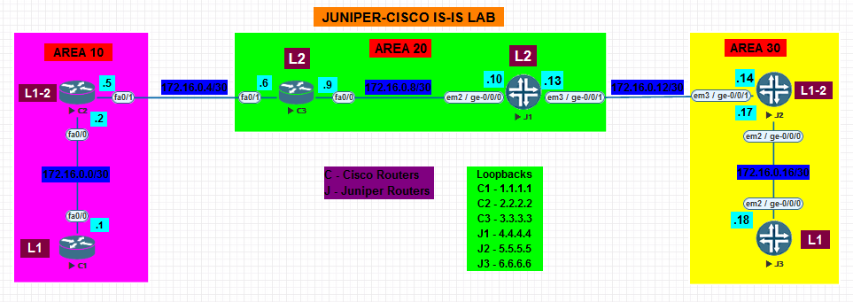

**NOTE: Perform All the basic factory-default, root password and System hostname configuration on Juniper Router before performing the lab. (Given in Static Routing Lab)**

* **In the above given topology,**
* **C1 and C2 routers belong to Area 10**
* **C3 and J1 routers belong to Area 20**
* **J2 and J3 routers belong to Area 30**
* **C1 and J3 are L1 routers**
* **C2 and J2 are L1-2 routers**
* **C3 and J1 are L2 routers**

1. **Configure the respective physical interfaces & also configure the loopback interfaces on all the routers in the configuration mode as per the network topology**

**CISCO Routers  
C1: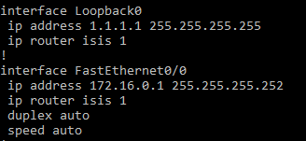 C2: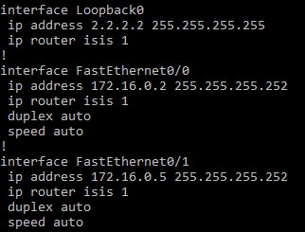 C3:**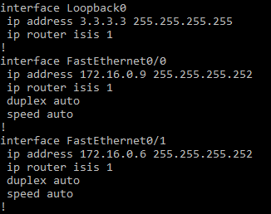

**JUNIPER Routers:**

**J1:**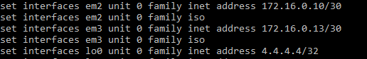

**J2:**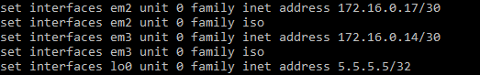

**J3:**

1. **Verify using the show command that all the interfaces are configured correctly.**

**CISCO Routers  
C1: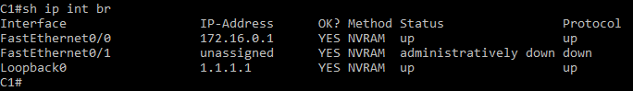 C2: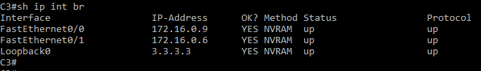 C3:**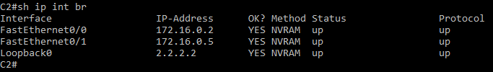

**JUNIPER Routers:**

**J1:**

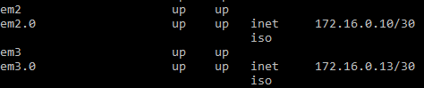



**J2: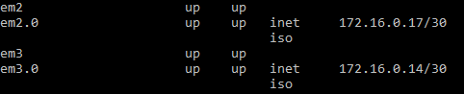 J3:**

1. **Configure IS-IS on all the Cisco Routers as per the topology. C1 is L1 router, C2 is L1-2 Router and C3 is L2 Router. Also enable IS-IS on interfaces as well as loopbacks.**

**CISCO Routers  
C1: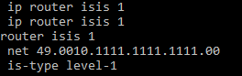 C2:**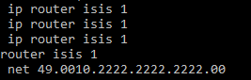

**C3:**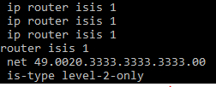

1. **Configure IS-IS on all the interfaces of Juniper Routers as per the topology.**

**JUNIPER Routers:**

**J1:**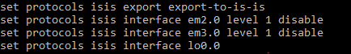

**J2:**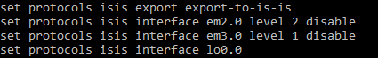

**J3:**

1. **Configure the interfaces in ISO family and also configure the clns address for loopback interface.**

**JUNIPER Routers:**

**J1:**

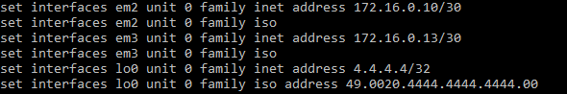

**J2: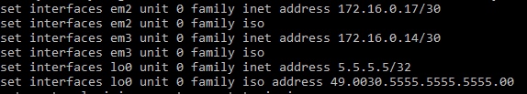 J3:**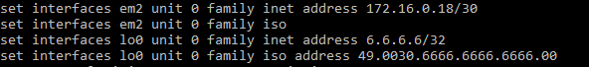

1. **Configure Policy statements on IS-IS router for accepting and sending routes to the routers.**

**JUNIPER Routers:**

**J1:**

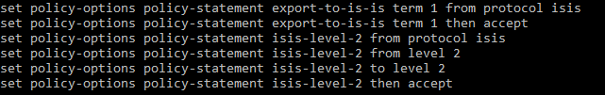

**J2: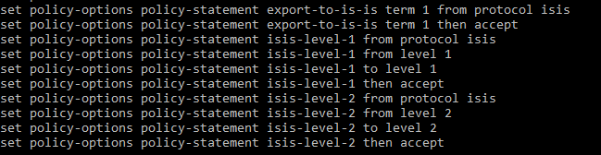 J3:**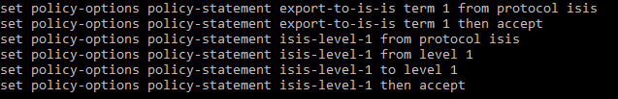

1. **Verify IS-IS neighborship on all routers.**

**CISCO Routers  
C1:**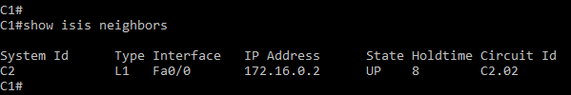

**C2:**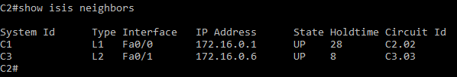

**C3:**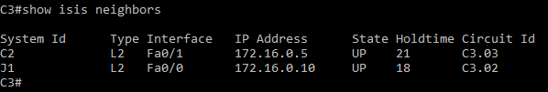

**JUNIPER Routers:**

**J1:**

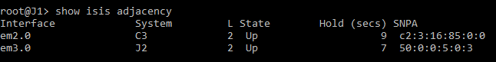

**J2:**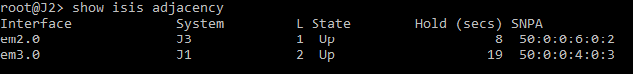

**J3:**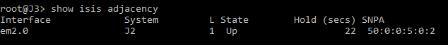

1. **Verify IS-IS database on all routers.**

**CISCO Routers  
C1: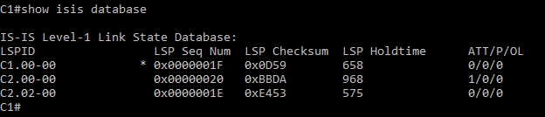 C2:**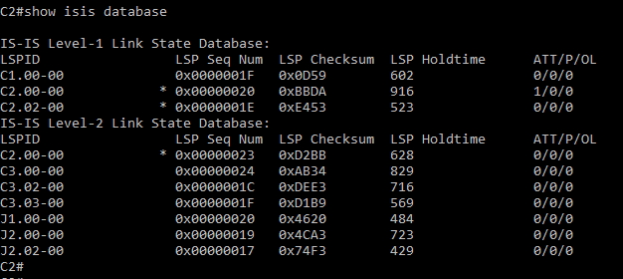

**C3:**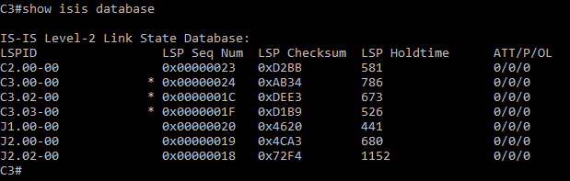

**JUNIPER Routers:**

**J1:**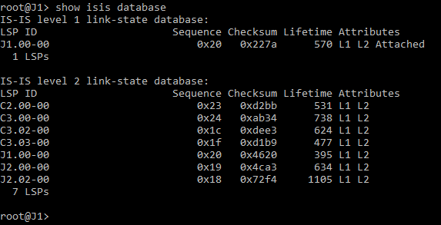

**J2: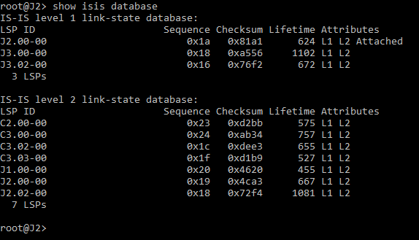 J3:**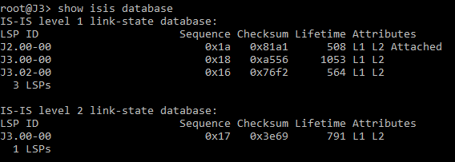

1. **Verify Routing table for all the Routers.**

**CISCO Routers  
C1:**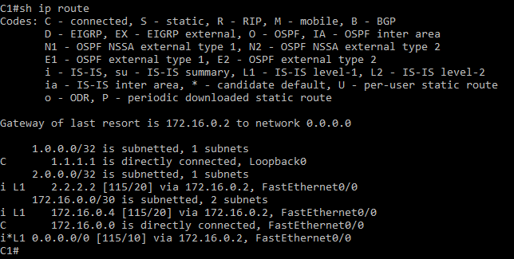

**C2:**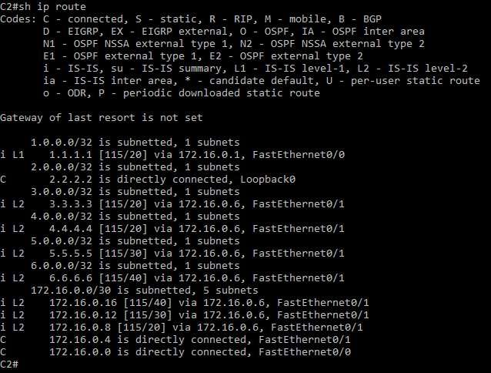

**C3:**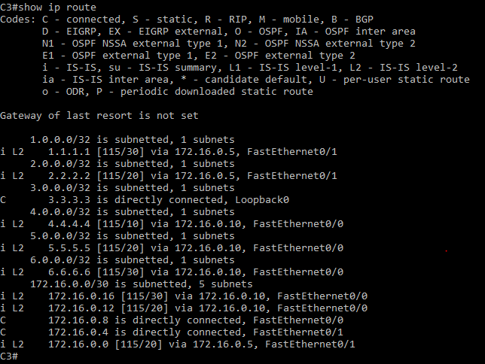

**JUNIPER Routers:**

**J1:**

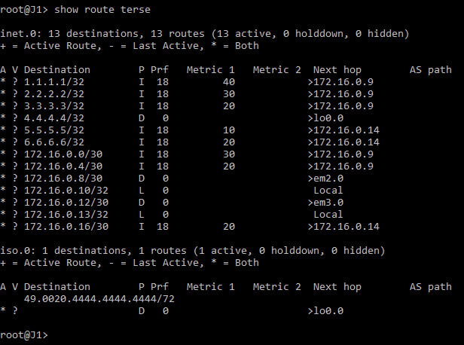

**J2: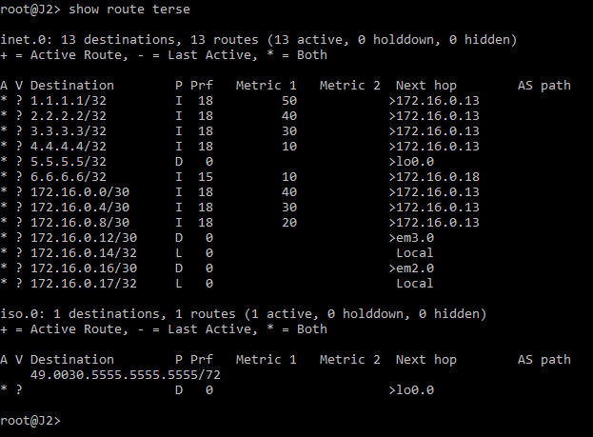 J3:**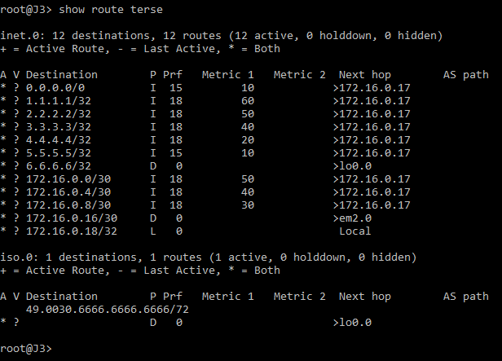

1. **Verify end to end connectivity.**

**CISCO Routers  
C1:**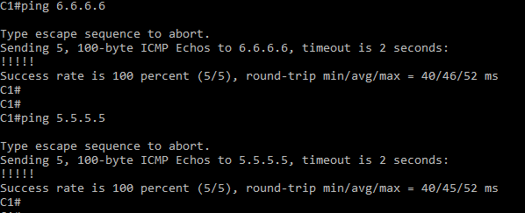

**JUNIPER Routers:**

**J3:**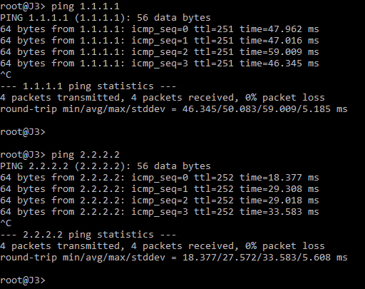

1. **Attach Screenshot of entire Juniper Configuration**

**JUNIPER Routers:**

**J1:**

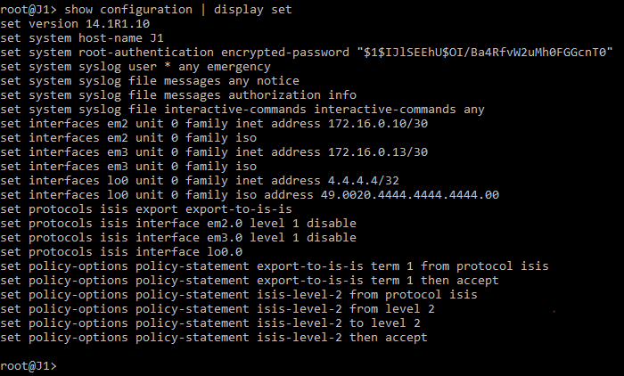

**J3:**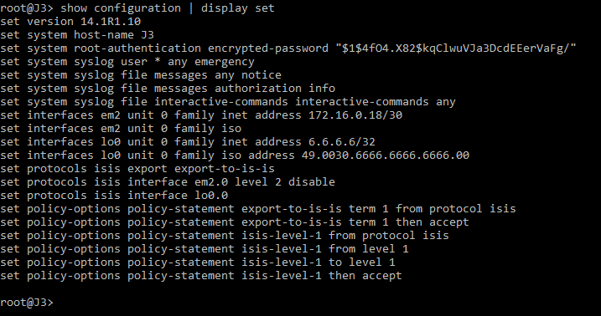

**J2:**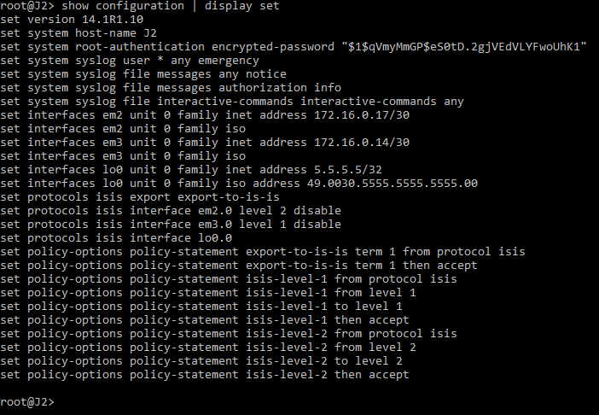

1. **Attach Screenshot for running configuration of Cisco and Juniper Router.**

**CISCO Router:  
C3:**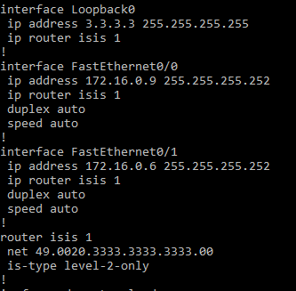

**JUNIPER Router:**

**J2:**